Chris Klassen – Melvin Loho – Jonathan Chu

BCIT  3700 Willingdon Avenue

Windows assignment 4 USer Guide

Table of Contents

Overview 2

Set Up 2

Client 2

Server 3

Usage 4

Server 4

Client 5

Troubleshooting 8

The Server Can’t Find My Music 8

The Server Can’t Open LibVLC 8

The Client Isn’t Receiving Unicast Data 9

The Client Can’t Connect To Multicast 9

The Client Can’t Connect To Other Clients 9

My Downloaded File Doesn’t Appear 9

# Overview

This guide is designed to help set up, troubleshoot, and use **Comm Audio**, the fourth Data Communications Windows assignment.

The guide is broken up into three main parts:

* Set Up
* Usage
* Troubleshooting

# Set Up

In order to use **Comm Audio**, you must first prepare your computer’s environment with the required system path and Visual C++ Redistributables.

## Client

To set up the client, the executable must be properly extracted from any zip files it may be part of.

Once that has been done, the Visual C++ Redistributable packages found at the following websites must be installed:

<http://www.microsoft.com/en-us/download/details.aspx?id=40784>

<http://www.microsoft.com/en-us/download/details.aspx?id=30679>

After installation, the final step involves installing **Qt** and setting up your system path to include the Qt bin folder.

To install Qt, visit <http://www.qt.io/developers/> and download the latest version. In the event that it has been installed to the default directory, add the following directory to your system path in environment variables:

C:\Qt*VERSION_NUMBER*\*COMPILER*\bin

In order to use the client beyond just local area network, the specified port range must be forwarded. This port range begins at the port passed in using arguments, and should extend 1 additional ports. (Eg. 9000 – 9001).

Once this has been completed, you should be able to run the Client without problems.

## Server

To set up the server, the executable must be properly extracted from any zip files it may be part of.

Once that has been done, the Visual C++ Redistributable packages found at the following websites must be installed:

<http://www.microsoft.com/en-us/download/details.aspx?id=40784>

<http://www.microsoft.com/en-us/download/details.aspx?id=30679>

In order to use the server beyond just local area network, the specified port range must be forwarded. This port range begins at the port passed in using arguments, and should extend 2 additional ports. (Eg. 9000 – 9002).

# Usage

Using **Comm Audio** is fairly simple and straight forward. This section delves into the steps necessary to properly start up both programs, as well as the full functionality of each.

## Server

To run the server, open command line and navigate to the directory of the server application. Run the server using the following command:

Server.exe [0/1] [port]

Running the server with the ‘0’ flag starts it in Multicast Mode. From here, the server will automatically retrieve the song list from the folder called “music” and select a song at random to play. The server will run until you close it, playing data to any number of clients.

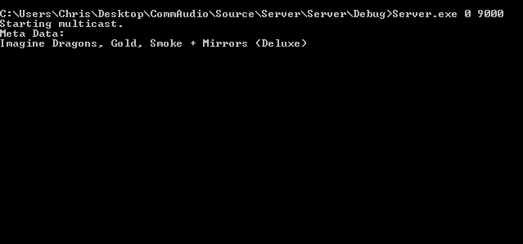

Running the server with the ‘1’ flag starts it in Unicast Mode. From here, the server will wait for clients to connect and fulfill their requests as they are made.

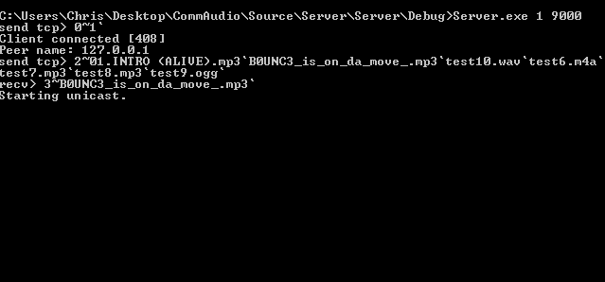

## Client

To run the client, simply double click the executable. You will be able to access the client, but will likely not be able to connect to the server or another client immediately.

When using the client to play music, you must first enter the Configuration Tab and enter the settings for the server, clicking “Save” afterwards. Once this has been done, you can go to the Multicast or Unicast tab and click “Connect”.

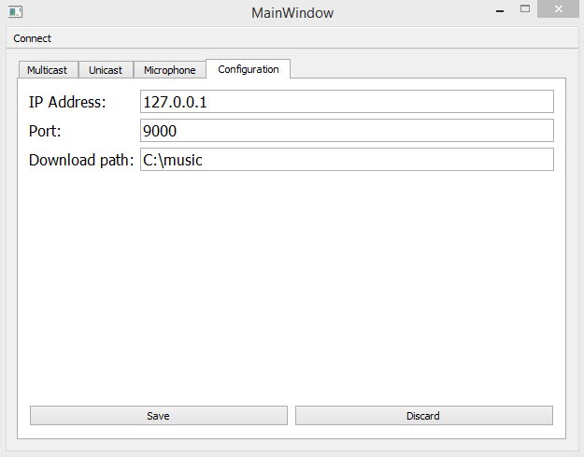

When connected in Multicast mode, you will be shown the metadata for the currently playing song, and audio will stream to your device.

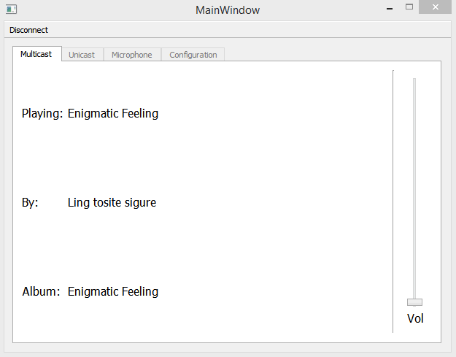

When connected in Unicast mode, you will be given a list of songs that you can choose from. When you select a song, you can **Stream** or **Download** it. Streaming will play it directly to your speakers. Downloading it will place it in the directory that you selected for downloading.

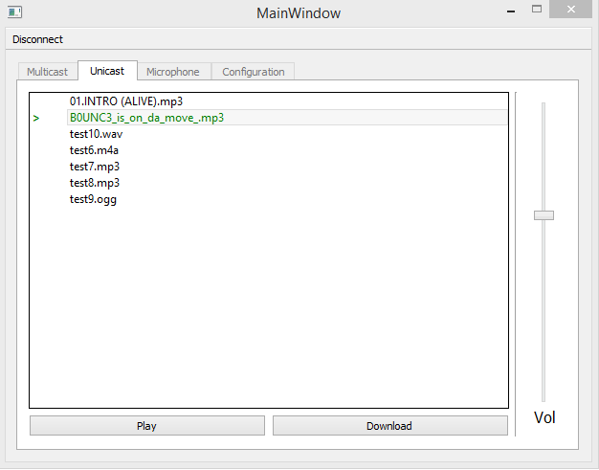

When using the client to communicate via microphones, you must have two clients running. Both clients must enter the IP addresses and ports of the other client, and then connect. Once you connect, you can stream microphone audio to the other client and receive their audio.

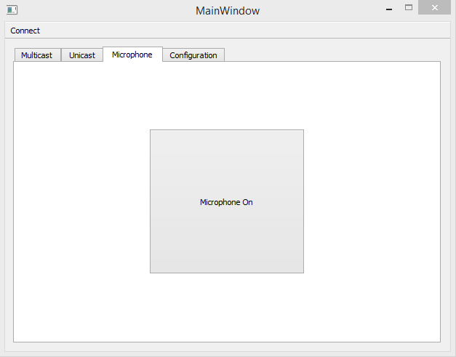

# Troubleshooting

If you are having problems running **Comm Audio**, you can use this section to troubleshoot common issues that you might run into.

## The Server Can’t Find My Music

Make sure that your “music” folder is in the same directory as your server’s executable, and that you have at least one song inside the folder.

## The Server Can’t Open LibVLC

Make sure that you have put both included DLLs into the same folder as your server’s executable, as well as the ‘vlc’ and ‘plugins’ folders.

## The Client Isn’t Receiving Unicast Data

If your client is not receiving any data from the server in Unicast mode, try the following things:

* Make sure that you have opened the range of ports specified for it.
* Make sure that the server is running.
* Make sure that the server has opened the range of ports specified for it.
* Make sure that you are connecting to the correct IP and port.

## The Client Can’t Connect To Multicast

If your client cannot connect to the server in Multicast mode, try the following things:

* Make sure that the server is running.
* Make sure that the server has opened the range of ports specified for it.
* Make sure that the router you are running your program on supports and has enabled Multicast
* Make sure that you are connecting to the correct IP and port.

## The Client Can’t Connect To Other Clients

Make sure that both clients have specified the correct IP and port, and that your microphone is both on and enabled within the application.

## My Downloaded File Doesn’t Appear

If your downloaded files do not appear, try the following things:

* Make sure that you have specified the download location that you want in your Configuration tab.
* Make sure that the server has not removed the target file in the time since you started the program.